* **Setup**

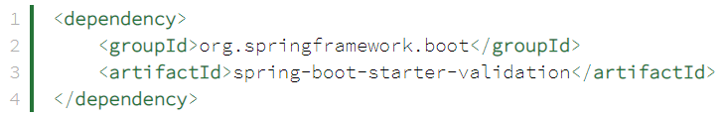

* **Automatic Validation With Spring**

Tự động inject Hibernate Validator nên không cần khởi tạo validator

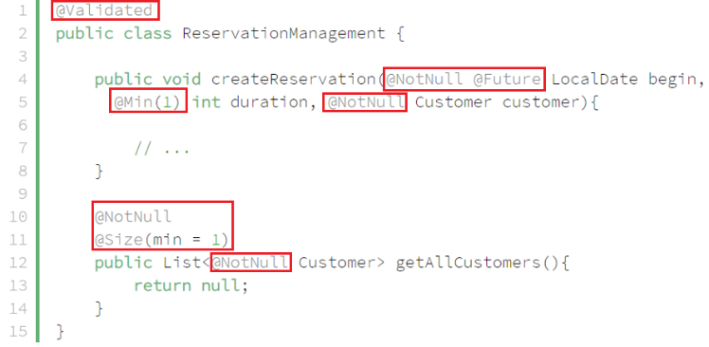

*Annotate the beans*

**Chú ý**: @Validated sẽ tự động parameter ở method của controller

VD: validate group

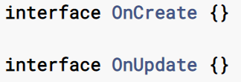

*Define group interface*

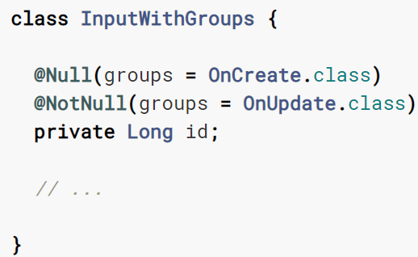

*Entity needed validating*

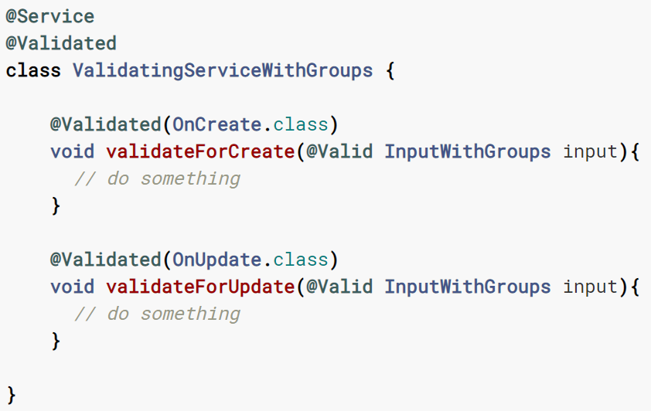

*Using*

[*https://reflectoring.io/bean-validation-with-spring-boot/#using-validation-groups-to-validate-objects-differently-for-different-use-cases*](https://reflectoring.io/bean-validation-with-spring-boot/#using-validation-groups-to-validate-objects-differently-for-different-use-cases)

* Throw ra **javax.validation.ConstraintViolationException** (thay cho MethodArgumentNotValidException).

Muốn throw ra MethodArgumentNotValidException thì làm như sau:

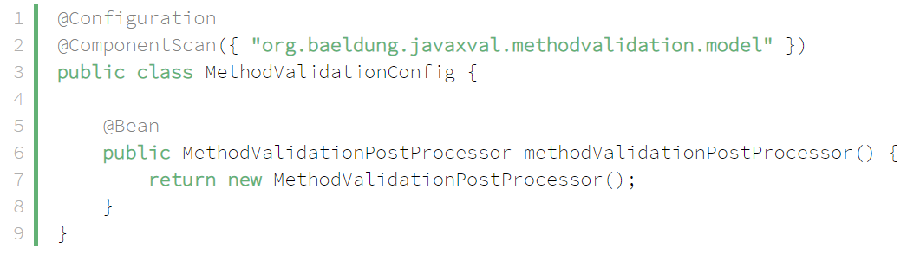

*MethodValidationPostProcessor bean*

* **Handling Exception**

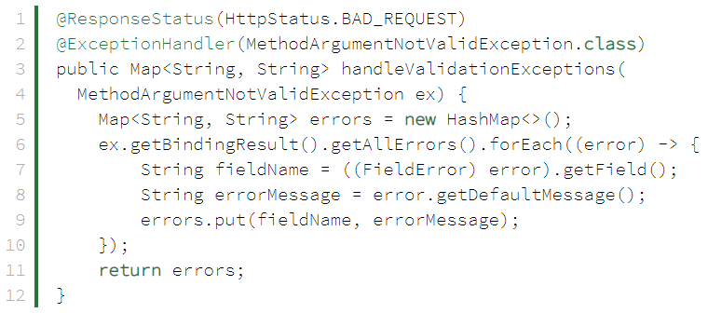

*MethodArgumentNotValidException*

* **Reference**

<https://www.baeldung.com/javax-validation-method-constraints#1-automatic-validation-with-spring>

<https://www.baeldung.com/spring-boot-bean-validation>

<https://howtodoinjava.com/hibernate/hibernate-validator-cdi/>

<https://docs.jboss.org/hibernate/stable/validator/reference/en-US/html_single/#section-integration-with-cdi>